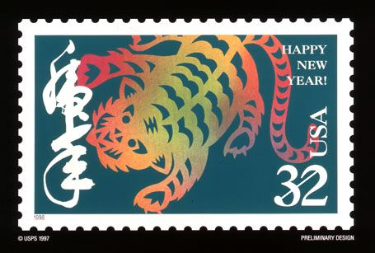

!!! KUNG HEI FAT CHOY !!!

January 28th, 2006
Hi

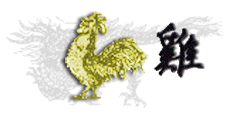
I will write this letter today – Saturday – instead of tomorrow as I have nothing else to do at the moment. Tomorrow is Chinese New Year’s day when the Year of the Rooster ends and the Year of the Dog takes over. With bird flu around, I guess the more superstitious people are not unhappy to see the Year of the Rooster pass. However, the dog is not supposed to be an auspicious animal, though right at the moment I cannot remember why not. Today and the next 3 days are public holidays in HK. A lot of people have gone on holiday it seems. A record number of flights left the airport yesterday – more than 800. It is going to be a wet New Year. There has been drizzle today with more tomorrow though by the time of the fireworks over the harbour on Monday evening, the weather should be better. It is not that cold, with maximum temperatures in the range 18 - 21⁰C. As a 'special guest’ of the hotel (whatever that means), I received a Chinese pudding for the New Year. Haven’t eaten any of it yet – not even sure whether it is to be eaten raw or cooked in some way. Will find out.
Gavin – you are a rooster!! Leonie – you are a sheep! Nadine – you are an ox! While looking for pictures of animals on the web, found this about CNY celebrations in Manchester:
“Manchester welcomes the Year of the Dog with a glittering array of festivities including Dragon and Lion Dances, Kung Fu demonstrations, folk dance performances and stalls and workshops. The spectacular Golden Dragon Parade leaves Albert Square at 12.30pm and winds its way towards Chinatown. Around the streets of Chinatown, there will be special stalls and fairground rides, plus the chance to sample the delights of the surrounding restaurants and oriental shops. The official celebrations end at 5.30pm with a stunning firework finale at Faulkner Street Car Park.”
It was pullover temperatures for the run last Monday, though I took if off before an hour had gone. We ran from Tei Mei Tuk to Bride’s Pool and then to the coast and around to an old Hakka village, largely abandoned, at Lai Cho Wo; only saw one elderly woman there. Instead of returning to Tei Mei Tuk, ran a new route down to a place called Luk Keng, which is not far from the border village of Sha Tau Kok. Quite scenic too. Took 2 hr 52 min but that included several navigation stops for the new leg. So on the next run, I expect 5 minutes or more can be shaved off that time.
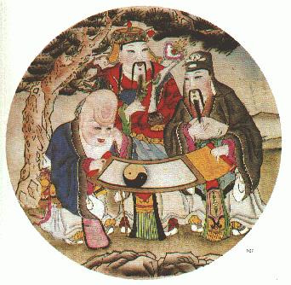
Interesting victory by Hamas – the terrorist organisation – in the parliamentary elections in Palestine. Now that they have political power, they may have to moderate their terrorist activities. This has happened before when military organisations have become the government of a country.
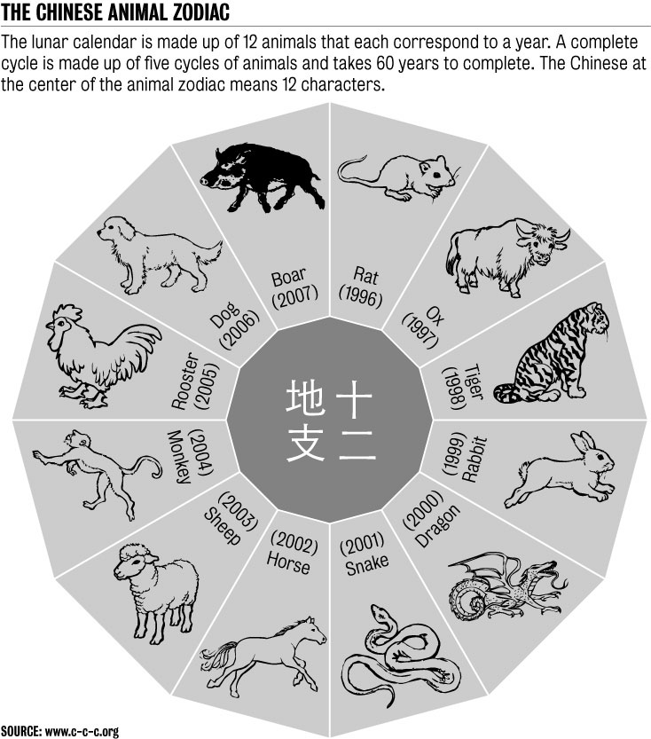
Yesterday, January 25th was the 250th birthday of Mozart! You probably are aware of that, as it seems difficult to avoid with celebrations being held round the world. In Salzburg, Mozart’s birthplace, there are many music festivals, with every piece of music Mozart composed to be played!! This includes performances of all 22 operas. Seems a bit overdone. Here in HK, there has been a lot is the past few months about the event on Radio 4. And yesterday, every piece of music broadcast by the station was by Mozart! Radio 4 also had an Internet poll for us to choose which of some pre-selected Mozart compositions we thought were best. All entries go into a hat and the winners receive a free trip to Salzburg. I guess it will not be my name that is drawn!
Some good workouts in the gym this past week. The two treadmill runs were faster than in previous weeks, and today, the 15-min row in middle of weights workout averaged 2:01.6 min per 500 m compared with 2:03.8 last week.
Another dead local bird found to have a flu virus though it has not yet been confirmed whether it is the H5N1 virus or not.
That’s about it for now; can’t think of anything else to write about.

Cheers.

